- Install Terraform on your PC
Step 1: Download Terraform
- Go to the official Terraform downloads page:
- https://developer.hashicorp.com/terraform/downloads
- Download the Windows 64-bit zip file.
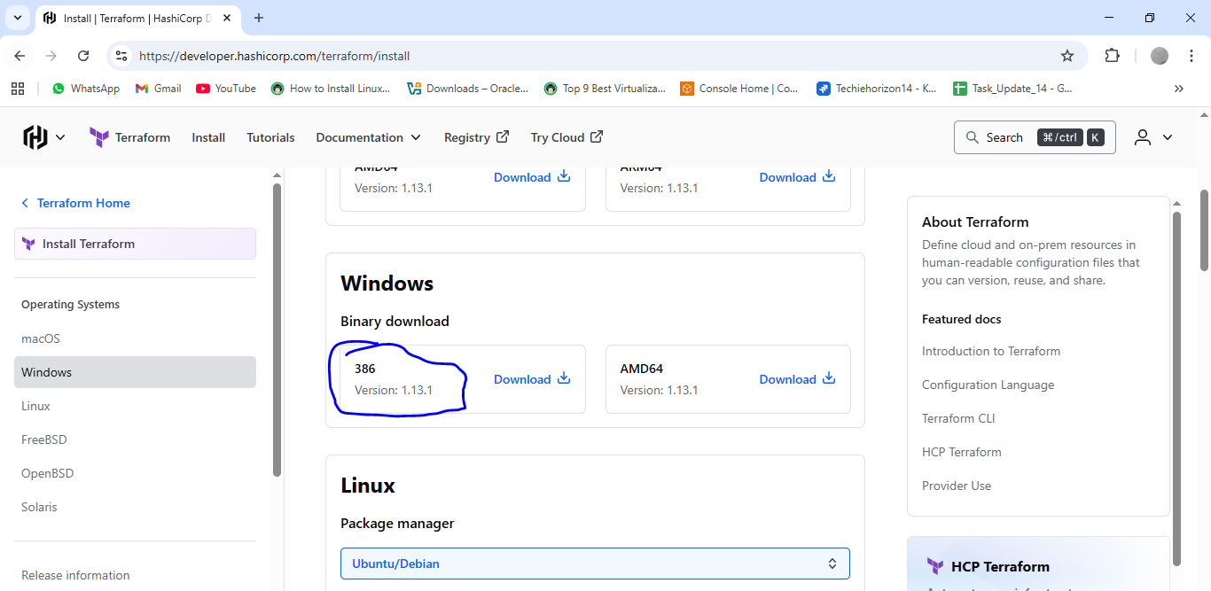
Step 2: Extract Terraform
- Unzip the downloaded file (it contains a single terraform.exe file).
- Move terraform.exe to a folder (e.g., C:\terraform).
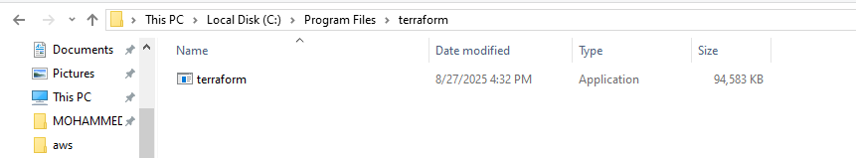
Step 3: Add to PATH
- Search for Environment Variables in Start menu.
- Click Environment Variables… → Select Path → Edit.
- Add the folder path where you placed terraform.exe (e.g., C:\terraform).
- Click OK.
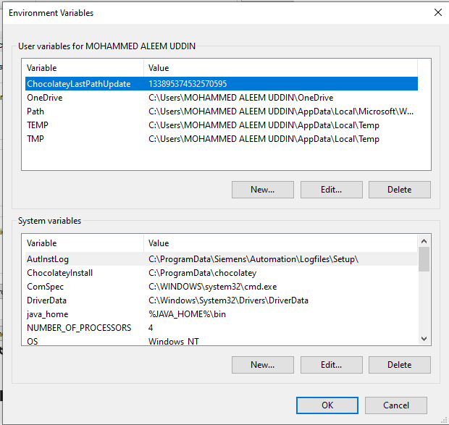
Step 4: Verify Installation
Open Command Prompt / PowerShell and run:
terraform –version
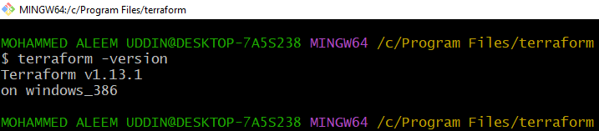
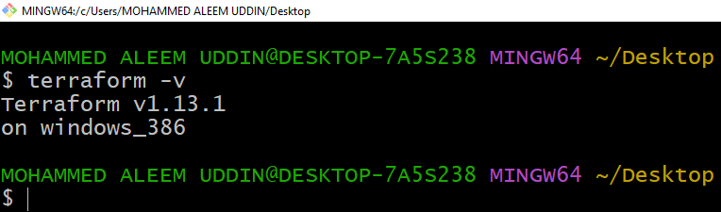
First, we should create one folder in Desktop
Open visual studio and select created folder
In Extensions search Hashi Corp Terraform and Install this Plugin
This will help us to correct the speeling mistakes spaces this will deacted automatically and it will give suggestions
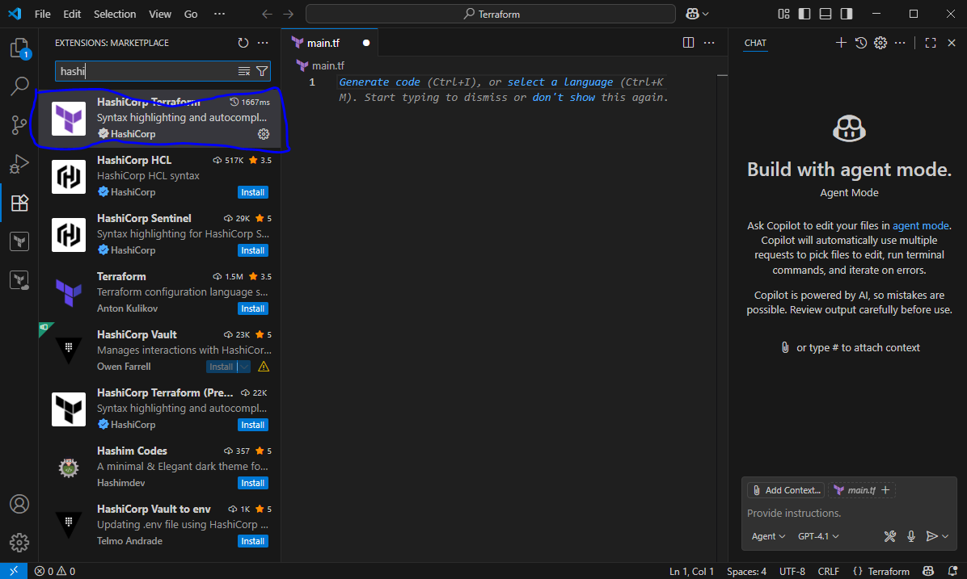
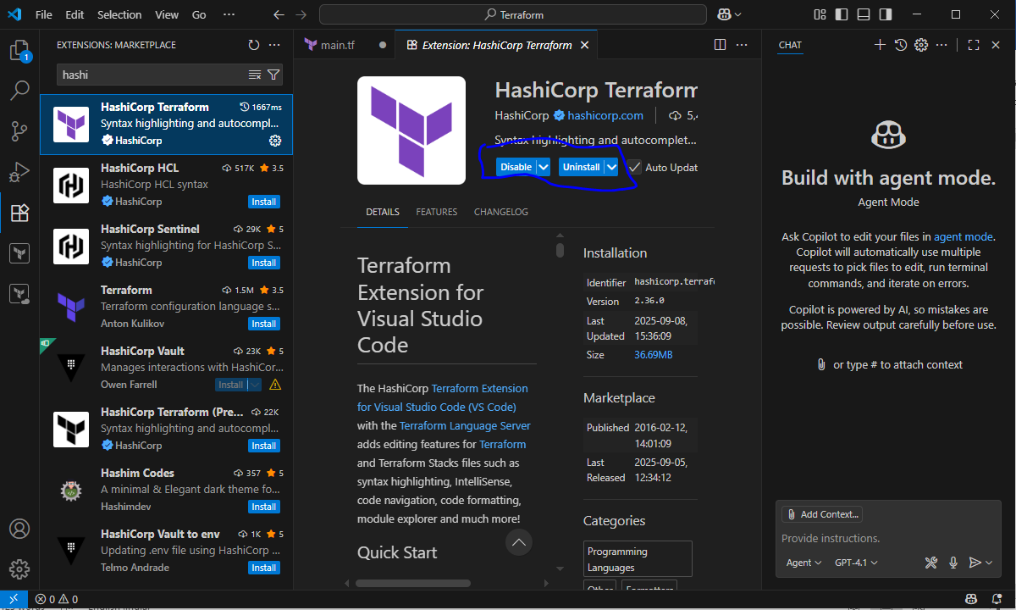
2) Execute all the templates shown in video.
Jenkins master ec2 need installations below:
sudo yum install -y yum-utils shadow-utils
sudo yum-config-manager --add-repo https://rpm.releases.hashicorp.com/AmazonLinux/hashicorp.repo
sudo yum -y install terraform
Create one file extension should be .tf
Resource block
Local Provider
Type type of resource
My_pet name of terraform
Filename & content attributes used for the resource
Add the terminal
before executing the code first, we need to initialized
Terraform init It will install all the dependencies of local file
One directory has been created. .terraform
.terraform has complete info has our provider
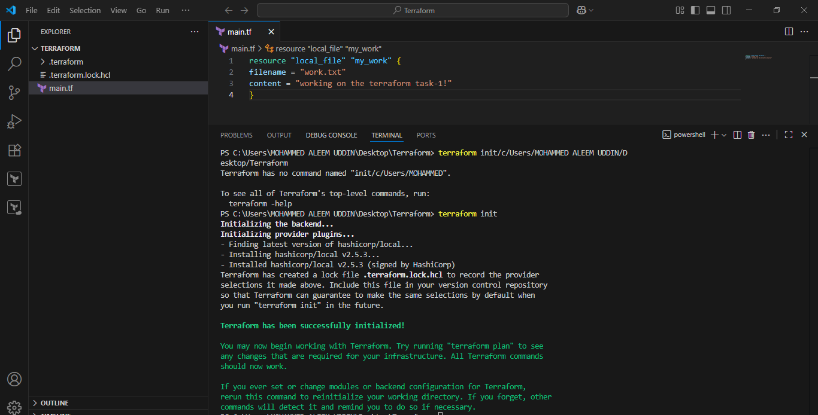
Terraform apply to execute and create the infra based on the configuration
Here I have modified the names. This has been replaced with new names
Modifications will show once we hit yes then only changes will apply
And this will execute
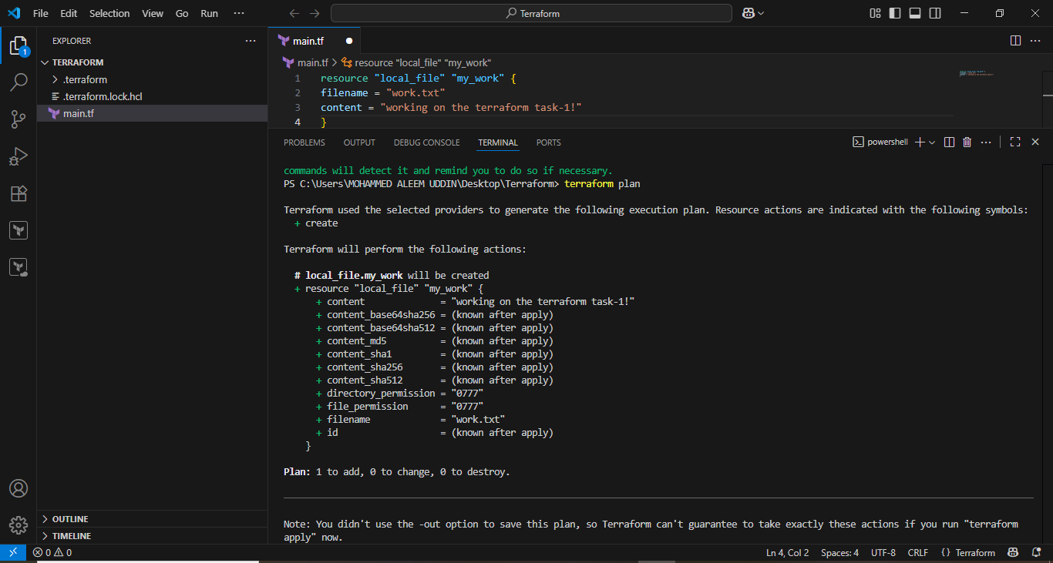
Terraform plan The terraform plan command is used to preview the changes Terraform will make to your infrastructure before actually applying them.
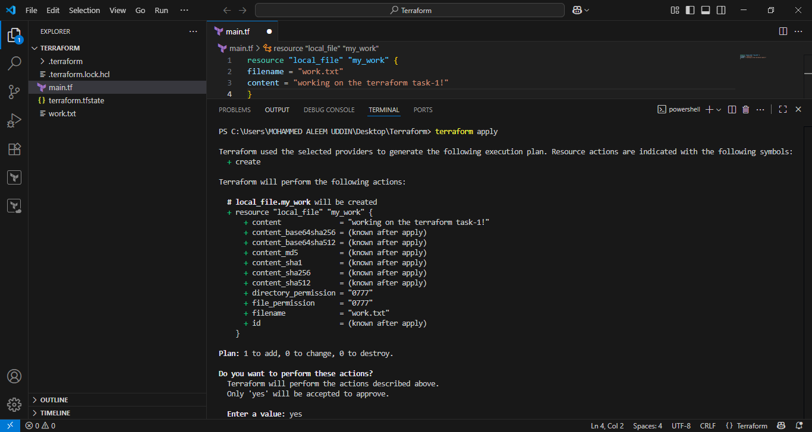
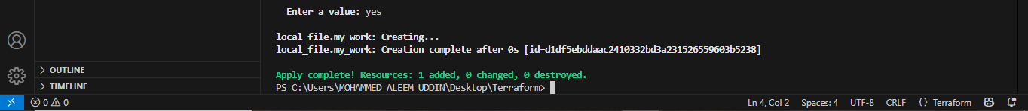
Now change the content in the file then check terraform init>plan>apply
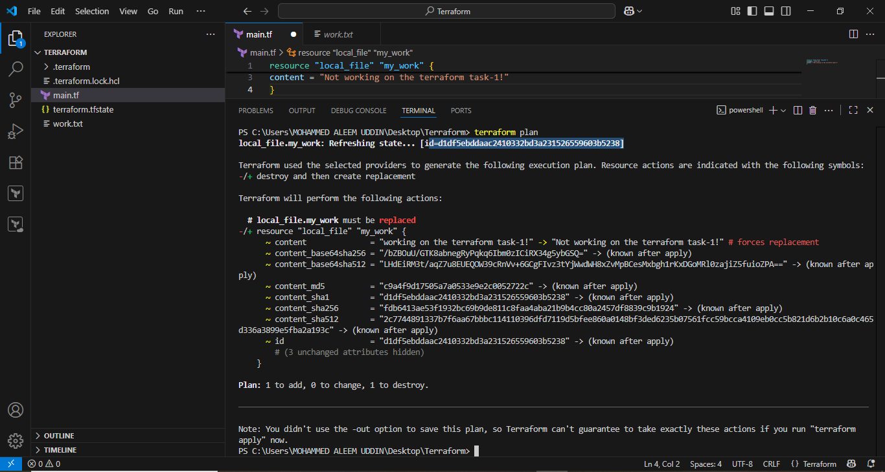
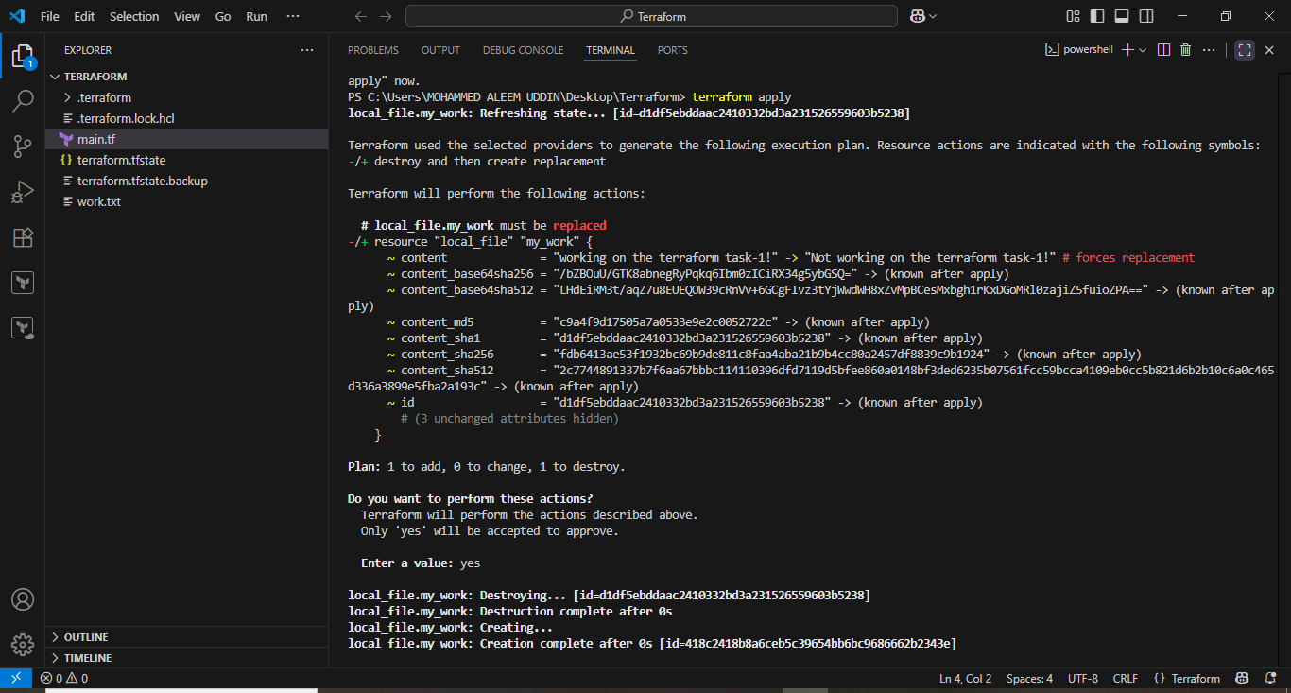
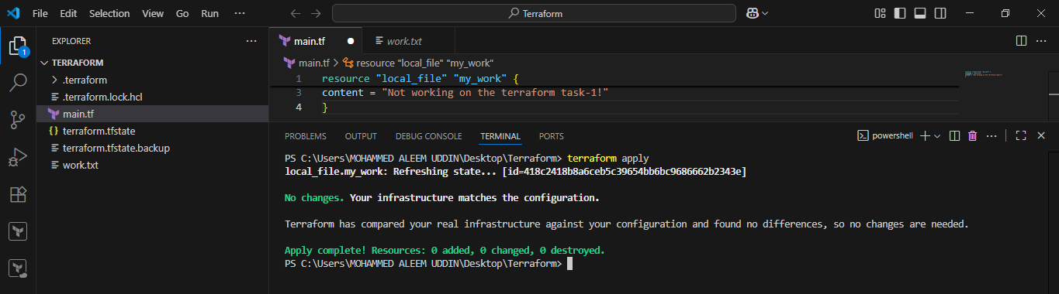
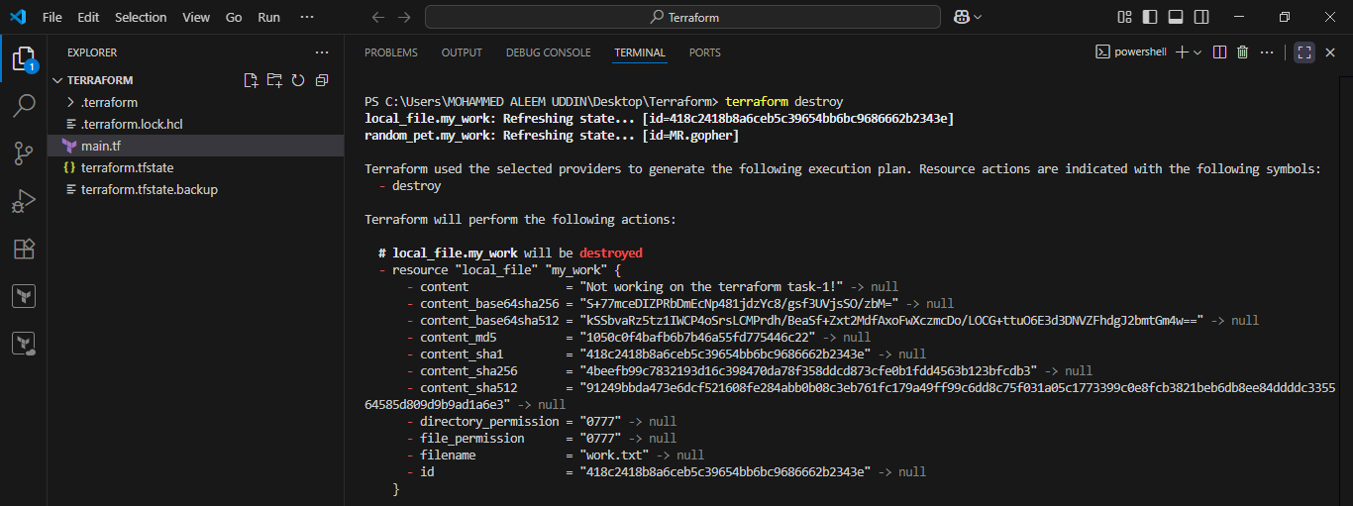
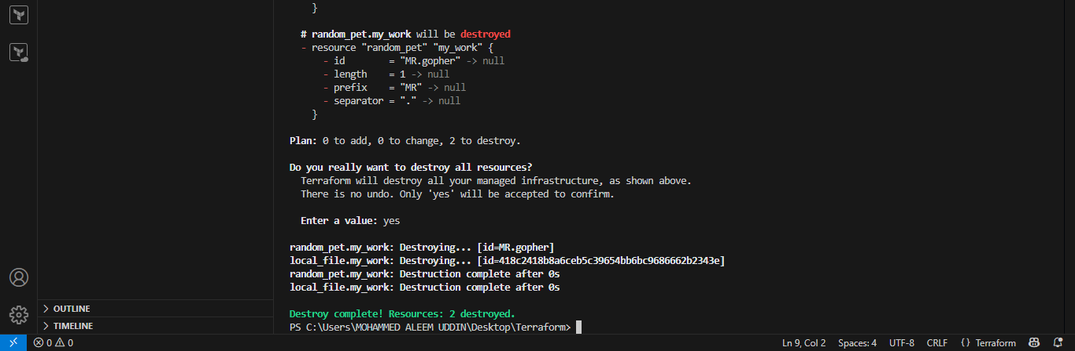
Second provider add Random_pet and execute commands.
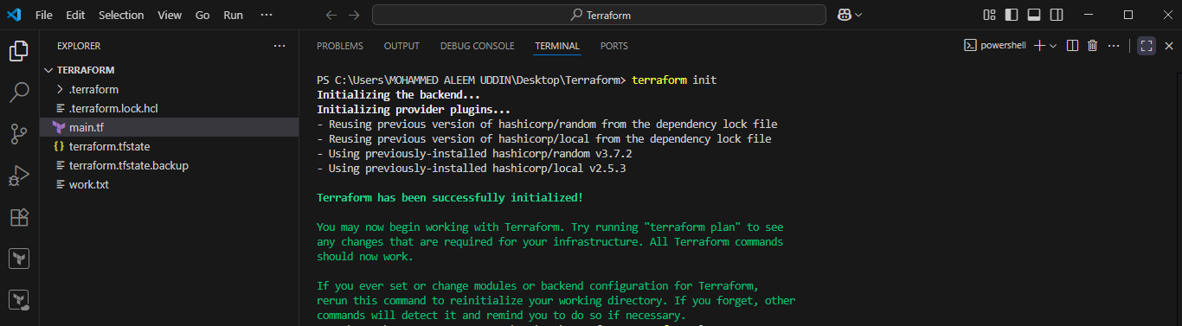
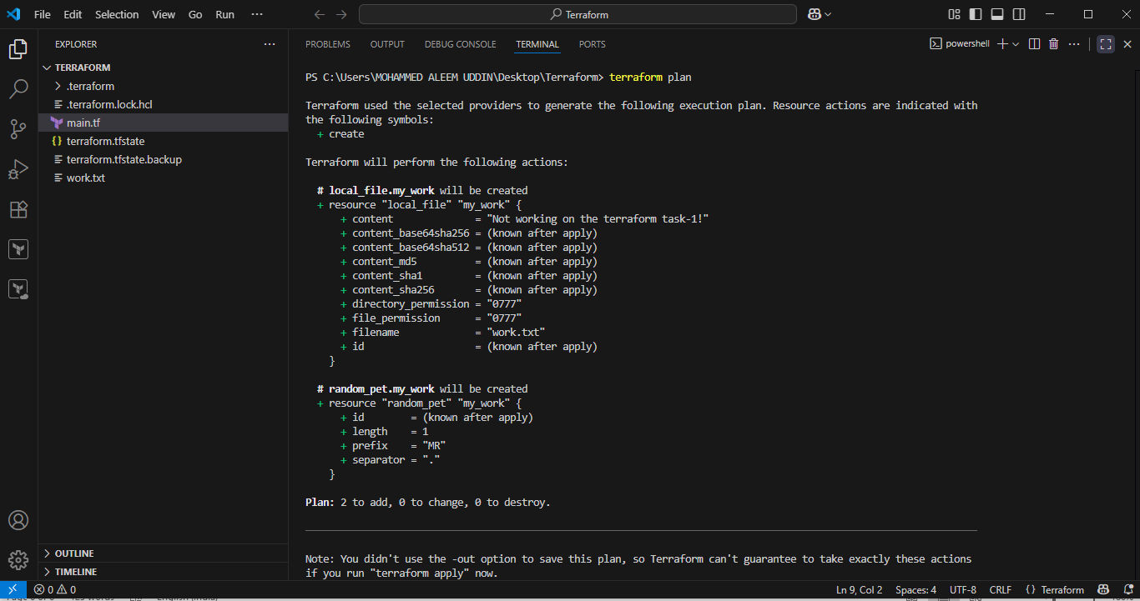
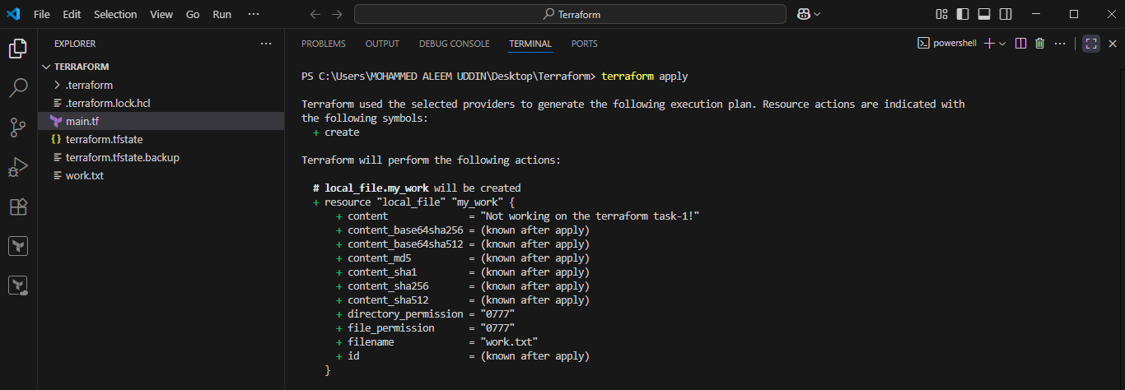
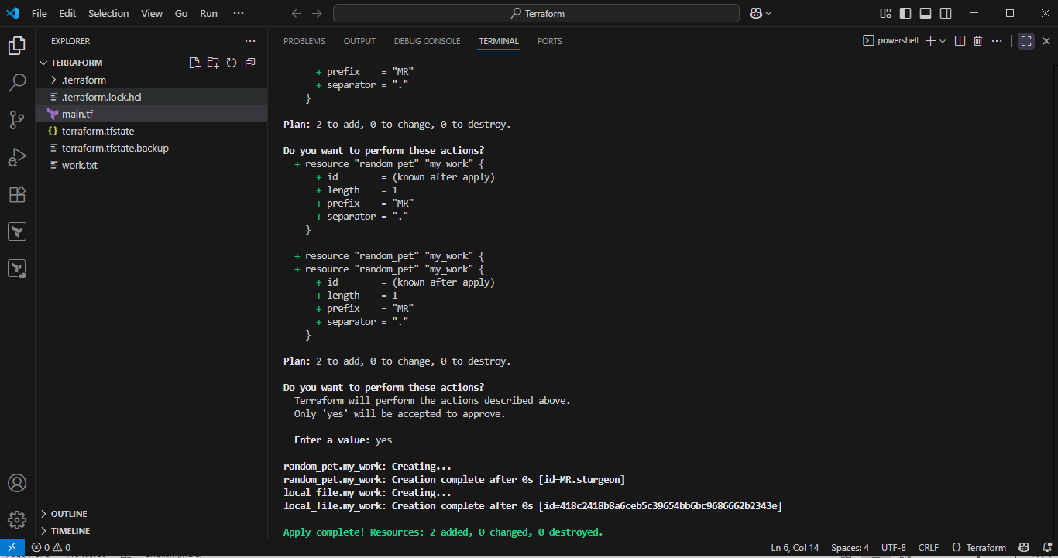
3) Note down below points
Terraform Init
Terraform Plan
Terraform Apply
Terraform Provider
terraform init Initializes a working directory for Terraform, It will install all the dependencies of local file
terraform Plan The terraform plan command is used to preview the changes Terraform will make to your infrastructure before actually applying them.
terraform Apply Executes the plan and provisions resources.
terraform Provider It is api call which is used to communicate with the resources, it can be aws,gcp,azure or local.
Providers are in three categories
1) Official --> provided by Hashicorp
2) Partner --> third party vendors
3) Community --> individual
4) Integrate a sample Terraform template in Jenkins
1. Install Jenkins and Terraform Plugin:
- Ensure Jenkins is installed and operational.
- Install the "Terraform" plugin through the Jenkins Plugin Manager (Manage Jenkins > Manage Plugins > Available plugins).
2. Configure Terraform Installation in Jenkins:
- Navigate to Manage Jenkins > Global Tool Configuration.
- Scroll to the "Terraform" section and add a new Terraform installation.
- You can choose to install automatically (Jenkins downloads a specific version) or point to an existing Terraform binary if installed manually.
3. Prepare your Terraform Code:
- Create a Git repository containing your Terraform configuration files (e.g., main.tf, variables.tf, outputs.tf).
- Include a Jenkinsfile in the root of your repository to define the Jenkins pipeline stages.
4. Create a Jenkins Pipeline Job:
- In Jenkins, create a new "Pipeline" job.
- Configure the job to use "Pipeline script from SCM" and point it to your Git repository and the Jenkinsfile.
5. Define the Jenkinsfile:
The Jenkinsfile will orchestrate the Terraform workflow. A basic example for applying a Terraform configuration might look like this:
Jenkinsfile:
pipeline {
agent any
environment {
AWS_ACCESS_KEY_ID = credentials('terraform-access')
AWS_SECRET_ACCESS_KEY = credentials('Terraform-secret')
}
stages {
stage('Checkout Code') {
steps {
git url:'https://github.com/ALEEMUDDIN138/Terraform.git', branch:'main'
}
}
stage('Terraform Init') {
steps {
sh 'terraform init'
}
}
stage('Terraform Plan') {
steps {
sh 'terraform plan'
}
}
stage('Terraform Apply') {
steps {
sh 'terraform apply --auto-approve'
}
}
}
}

Main.tf:
resource "local_file" "my_work" {
filename = "work.txt"
content = "Not working on the terraform task-1!"
}
- agent any: Specifies that the pipeline can run on any available agent.
- Checkout: Clones your Terraform repository. Replace your-git-credentials-id and your-terraform-repo-url with your specific details.
- Terraform Init: Initializes the Terraform working directory.
- Terraform Plan: Generates an execution plan and saves it to tfplan.
- Terraform Apply: Applies the planned changes. -auto-approve bypasses interactive confirmation.
6. Run the Jenkins Job:
- Save the Jenkins job configuration.
- Manually trigger a build or configure a SCM polling or webhook trigger for automated builds upon code changes.
This setup enables Jenkins to automate the execution of your Terraform templates, facilitating CI/CD for your infrastructure.
Create job and configure as below:
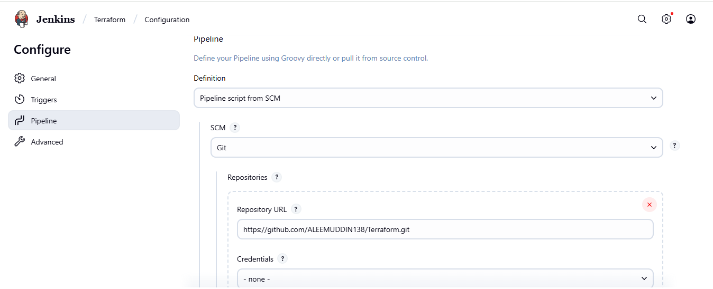
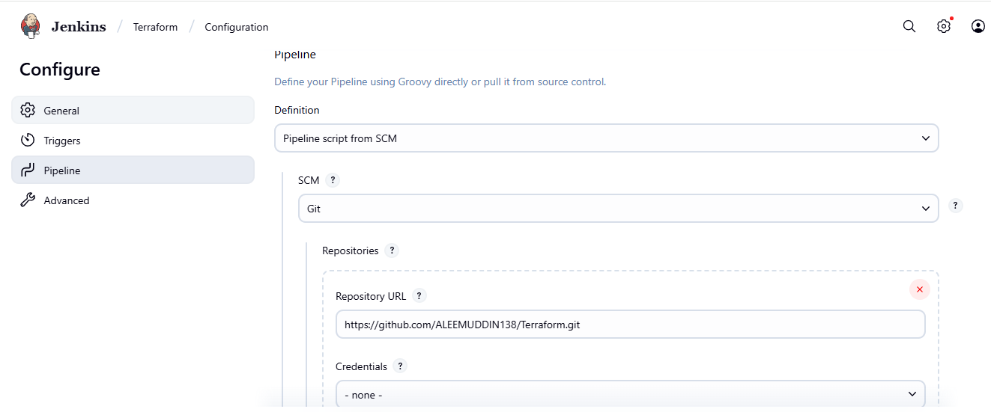Go to plugins and install Terraform
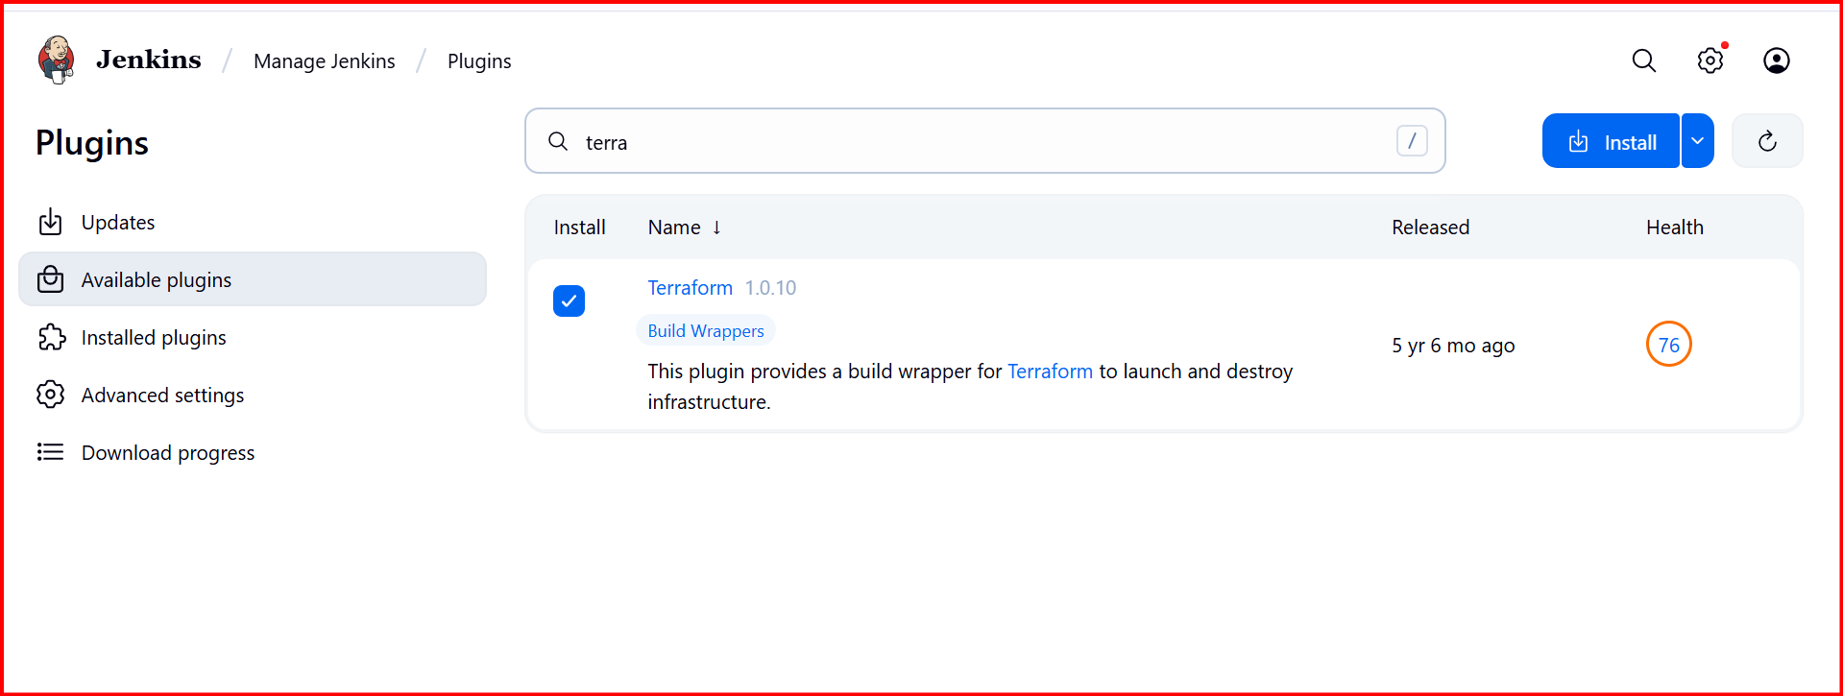
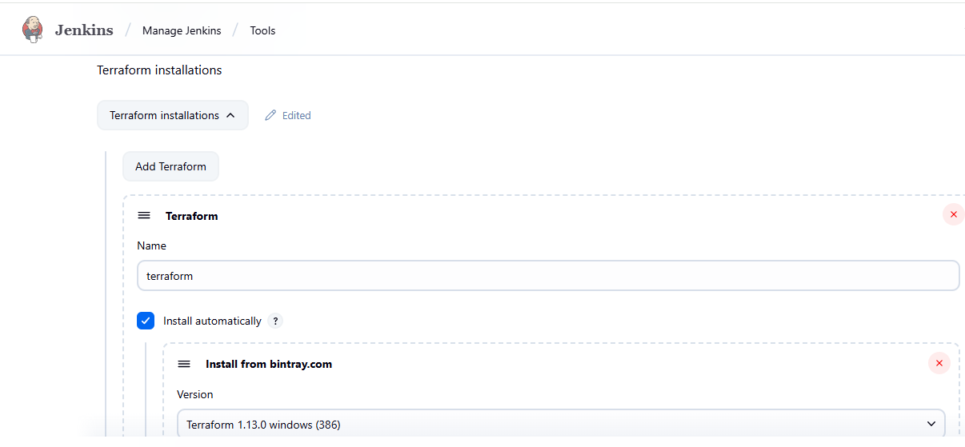
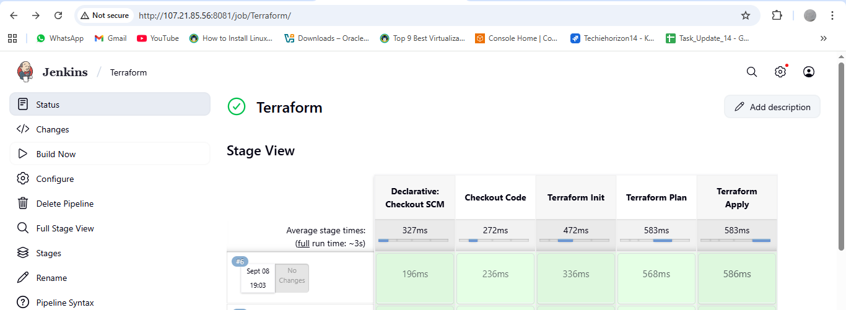

Now go to local machine and check provider file reflect in the work space.
